**Tugas Praktikum   
Pemrograman Berorientasi Objek**

“Tugas 04 - Polymorphism*”*

**Kelas A**



Oleh :

Muhamad Ihsan Setiawan

4523210069

Dosen :

**Adi Wahyu Pribadi**

**S1 Teknik Informatika**

**Universitas Pancasila**

**2023/2024**

**Single Inheritance**

**Mobil.java**

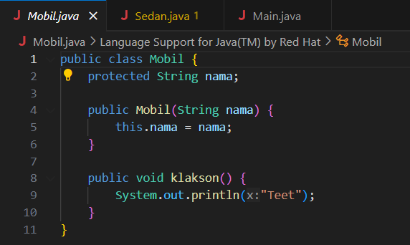

**Sedan.java**

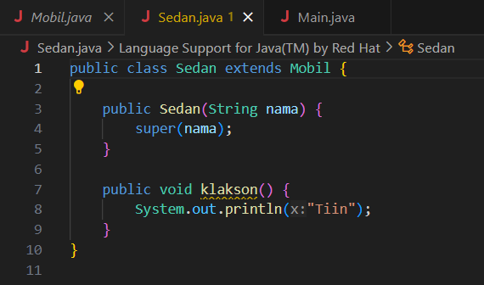

**Hasil Running**

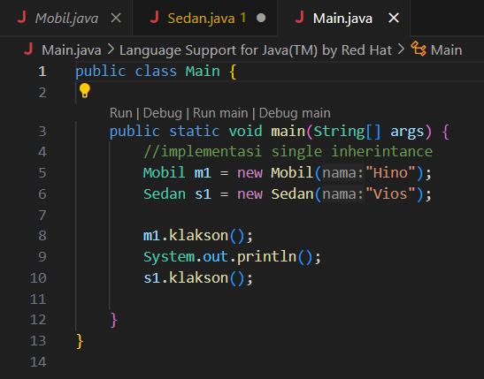

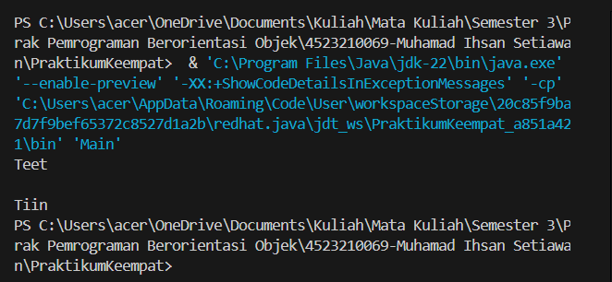

**Multilevel Inheritance**

**Binatang.java**

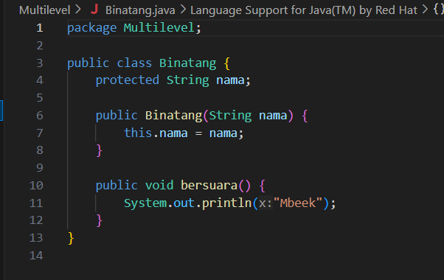

**Cemeng.java**

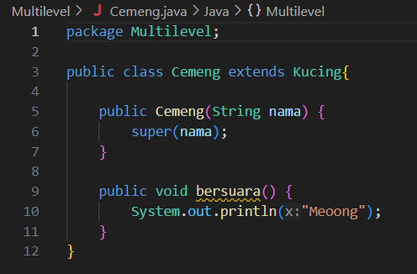

**Kucing.java**

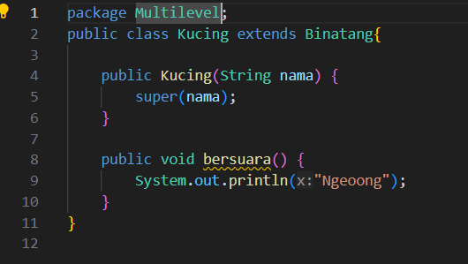

**Hasil Running**

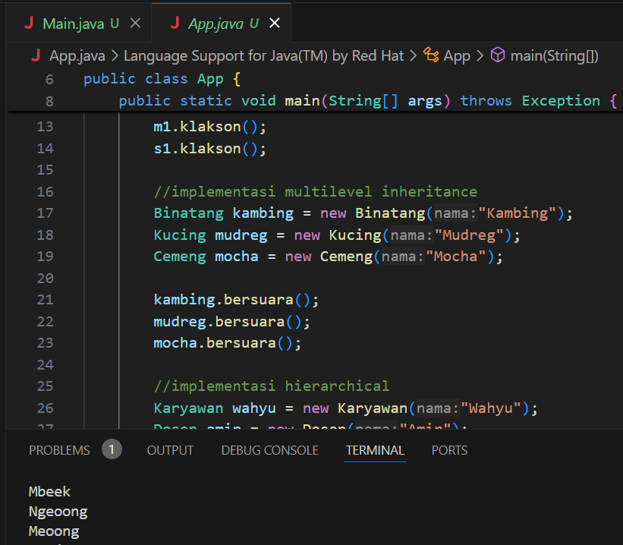

**Hierarchical Inheritance**

**Karyawan.java**

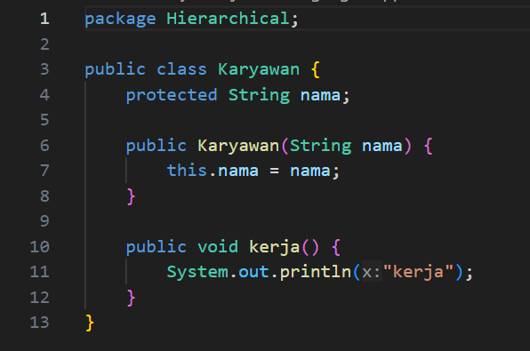

**Dosen.java**

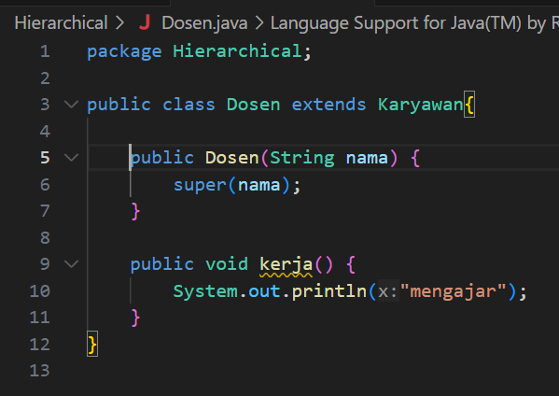

**Staff.java**

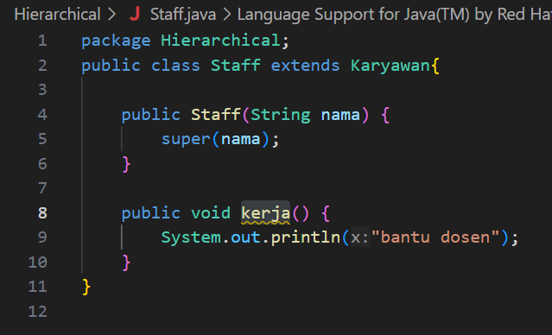

**Hasil Running**

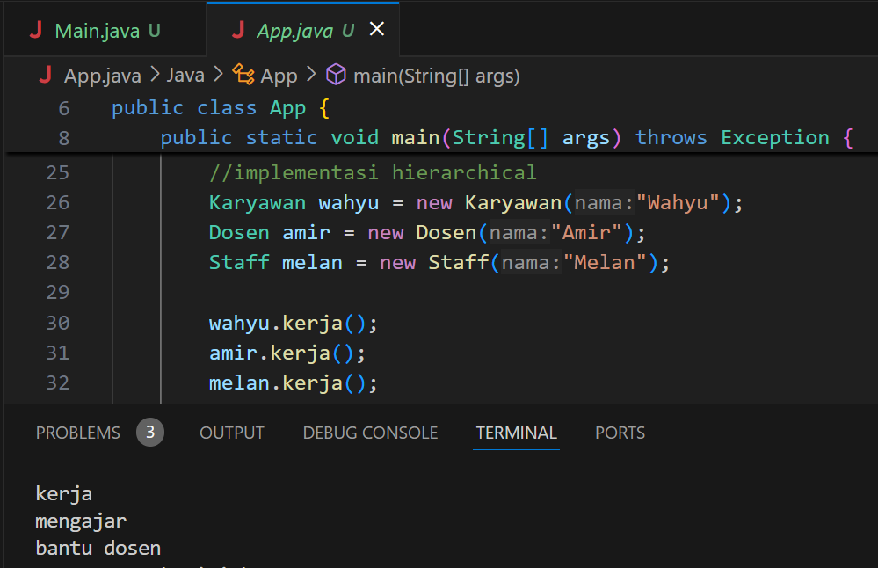

**Static Polymorphism**

**MobilSport.java**

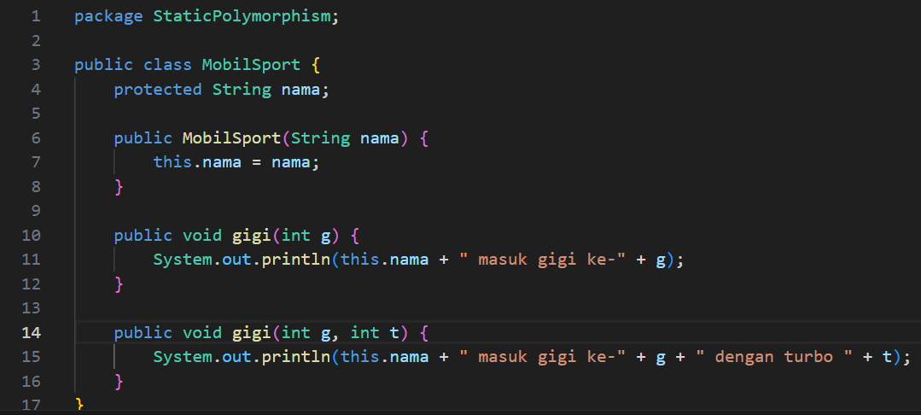

**Hasil Running** 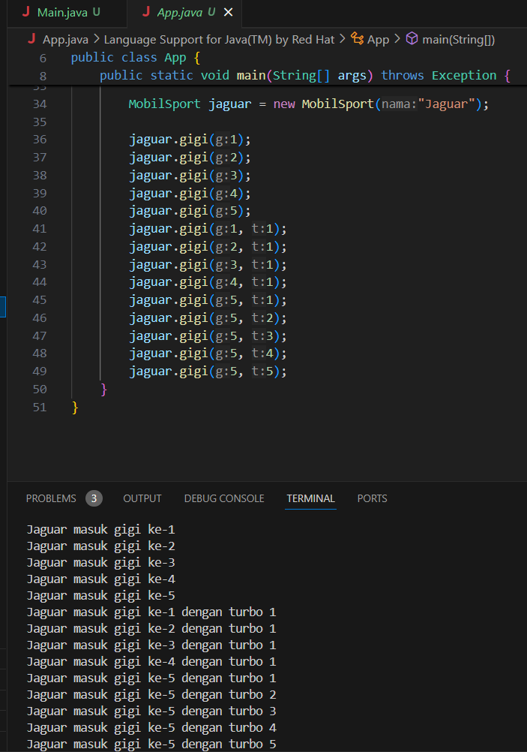

**Dynamic Polymorphism**

**BangunDatar.java**

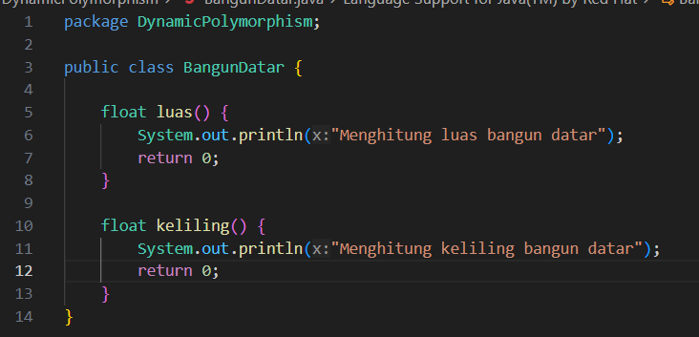

**Persegi.java**

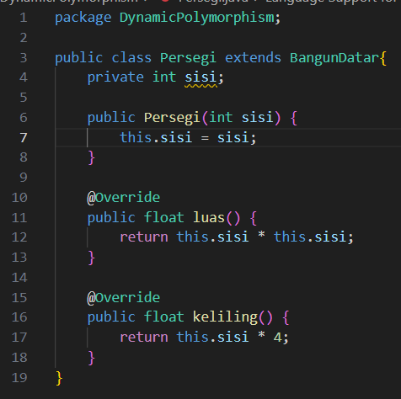

**Segitiga.java**

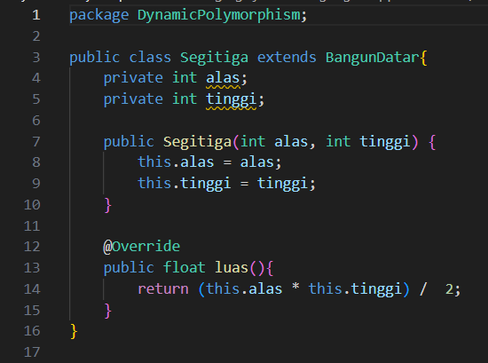

**Hasil Running**

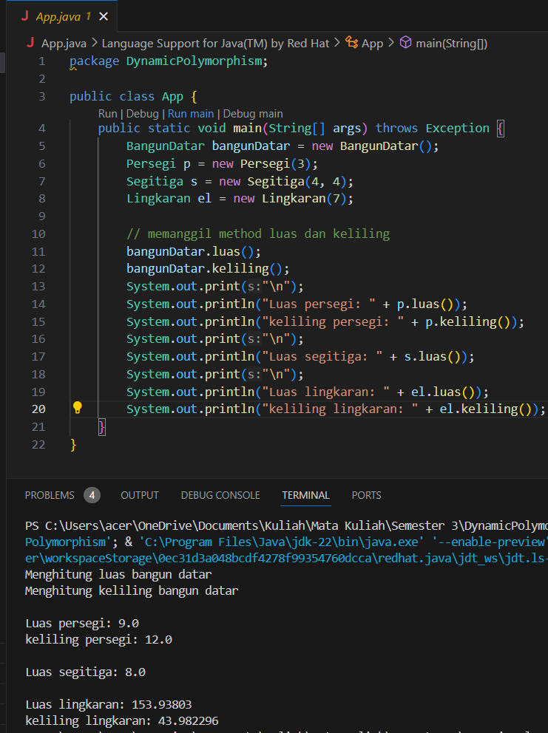

**Link GitHub:** https://github.com/icen6/Tugas-Praktikum-PBO.git